Session 5 - 1

import java.util.ArrayList;
import java.util.List;

class Solution {
public List<String> stringMatching(String[] words) {
List<String> result = new ArrayList<>();

for (int i = 0; i < words.length; i++) {
for (int j = 0; j < words.length; j++) {
// Ensure we don't compare a word with itself
if (i != j && words[j].contains(words[i])) {
result.add(words[i]);
break; // Break early to avoid duplicate entries
}
}
}

return result;
}
}

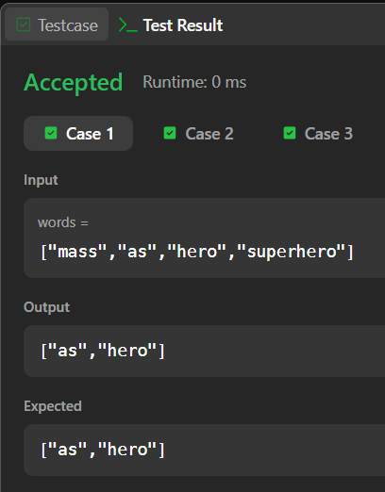

Session 5 - 2

import java.util.ArrayList;
import java.util.List;

public class Solution {

public static List<Integer> searchPattern(String text, String pattern) {
List<Integer> indices = new ArrayList<>();
int n = text.length();
int m = pattern.length();

// Loop through the text up to the point where the pattern can fully fit
for (int i = 0; i <= n - m; i++) {
int j;

// Check for a pattern match at the current starting position i
for (j = 0; j < m; j++) {
if (text.charAt(i + j) != pattern.charAt(j)) {
break; // Mismatch found, move to the next window position
}
}

// If the inner loop finished without breaking, a full match was found
if (j == m) {
indices.add(i);
}
}

return indices;
}

public static void main(String[] args) {
// Test Case from Image 1
String text1 = "aabaacaadaabaaba";
String pattern1 = "aaba";
System.out.println("Pattern found at indices: " + searchPattern(text1, pattern1));

// Test Case from Image 2
String text2 = "geeksforgeeks";
String pattern2 = "geeks";
System.out.println("Pattern found at indices: " + searchPattern(text2, pattern2));
}
}

